Report No. 11735

A350-1000F MDCLS Cargo Display Panel (CDP) Bootloader Software Requirement Specification

Module: | CDP BLSW SRS Module
Configuration Type: | 2023-11-20_CDP_BLSW_SRS_PH5_ENG_RELEASE
Configuration: | Baseline

ANCRA INTERNATIONAL, LLC
601 South Vincent Avenue
AZUSA, CA 91702

Ancra International LLC proprietary rights are included in the information disclosed herein. Recipient, by accepting this document, agrees that neither this document nor the information disclosed herein, nor any part thereof shall be reproduced or transferred to other documents or used or disclosed to others except as specifically authorized in writing by Ancra International LLC. Unpublished – all rights reserved under copyright laws.
© 2023 Ancra International LLC
Signature Page
Ancra Signatures
Prepared By: |  |  | 11/20/2023
 | Abdul Mubeen Mohammed |  | Date
Checked By: |  |  | 11/20/2023
 | Srividya Ganesh |  | Date
Approved By: |  |  | 11/20/2023
 | Thiru Ramasamy |  | Date

Revision Record
Rev.  Level | Rev.  Date | Prep.  By | Check.  By | Effected  Pages | Change  Description
A | 08/02/2023 | Abdul Mubeen Mohammed | Ravikumar Kannur | All | Initial Release  Corresponding Doors Baseline is  2023-08-02_CDP_BLSW_SRS_PH3_ENG_RELEASE and PR for the same is : A350 - 248
B | 11/20/2023 | Abdul Mubeen Mohammed | Ravikumar Kannur | All | Updated as per PR A350- 381 Corresponding Doors Baseline is:  2023-11-20_CDP_BLSW_SRS_PH5_ENG_RELEASE

Table of Contents
1 Scope 8
2 Referenced Documents 9
3 Acronyms & Initialism 10
4 Overview 13
4.1 Software Overview 13
4.1.1 CDP Boot software 14
5 Partitioning 14
6 Memory Constraints 14
7 High – Level Requirements 14
8 Requirements Traceability Matrix 23
9 Appendix A - DO-178C and Supplements Cross - Reference Matrix 24
10 Deleted Requirements 24

List of Figures
Figure 1 - CDP CIRD in Requirement Hierarchy 9
Figure 2 - CDP Software overview 14
Figure 3 - CDP State Diagram 15

List of Tables
Table 1 - Project Documents 10
Table 2 - Industry Standards 10
Table 3 - Customer Documents 10
Table 4 - Acronyms 13
Table 5 - SMARC module GPIO configuration 19
Table 6 - Forward Requirement Traceability Matrix 23
Table 7 - Backward Requirement Traceability Matrix 24
Table 8 - DO-178C Cross Reference Matrix 24

Scope
This Software Requirement Specification (SRS) defines the high level software requirement (HLR) required for certification of the Cargo Display Panel Boot Loader Software Computer Software Configuration Item (CSCI) of Main Deck Cargo Loading System MDCLS. Each HLR is tagged with a unique trace tag and bidirectional trace is provided between the HLR and the parent system level requirement that it was decomposed from.
This SRS also identifies derived requirements that do not directly trace to system requirement, but which are necessary to provide a complete description of all functions the software must provide. These derived requirements will be provided with justification for their existence in the SRS.
This document falls at Tier 2 of the requirement hierarchy,
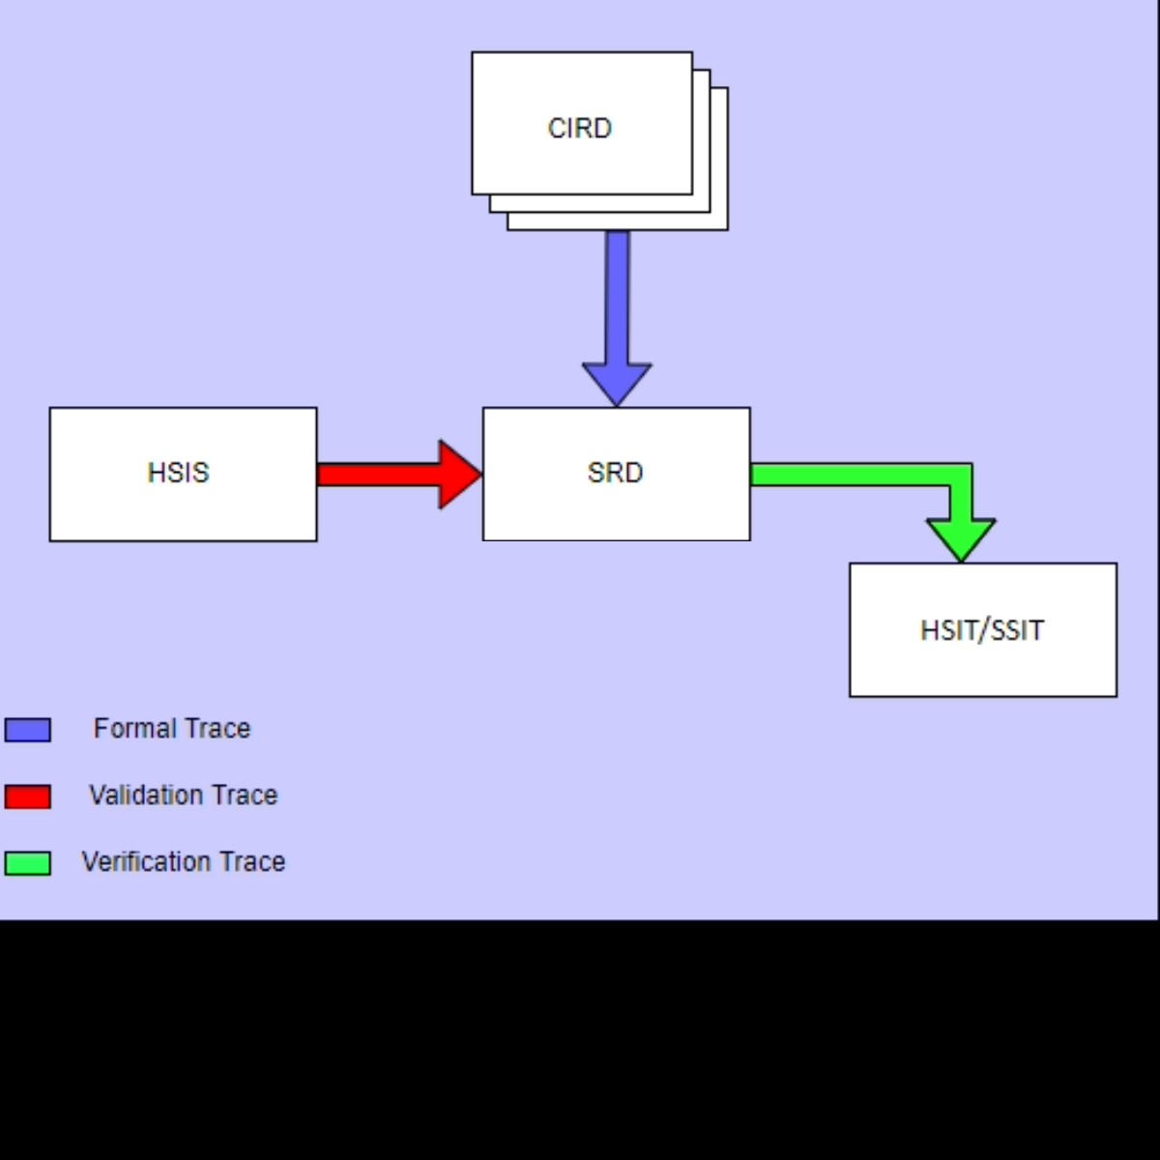
Figure 1 - CDP CIRD in Requirement Hierarchy

Referenced Documents
This section lists the project documents, customer documents, standards, procedures, government, and industry documents that are applicable to this document.

Document | Revision / Issue No | Title
11504 | B | Software Development Plan
11506 | B | Software and AEH Quality Assurance Plan
11507 | C | Software and AEH Configuration Management Plan
11644 | D | Plan for Software Aspects of Certification for CDP
11636 | A | CDP Configuration Item Requirements Document
11508 | C | Software Requirements Standards
11671 | B | Cargo Display Panel AEH Requirement Document
11672 | B | Cargo Display Panel AEH Software Interface Specification
11505 | C | Software Verification Plan
11594 | C | Interface Control Document for A350 Main Deck Cargo Loading System Controller Area Network
11595 | NA | Interface Control Document for A350 Main Deck Cargo Loading System Electrical
11632 | A | System Requirements Document (SysRD)
11751 | NA | Software Product Specification
Table 1 - Project Documents

Document | Description
ED-12C/DO-178C | Software Considerations in Airborne Systems and Equipment Certification
Table 2 - Industry Standards
Document | Description
NA | NA
Table 3 - Customer Documents

Acronyms & Initialism
Acronym | Definition
AC | Alternating Current
AEH | Airborne Electronic Hardware
AFDX | Avionics Full Duplex Switched Ethernet
AFT | Aft ward
ARINC | Aeronautical Radio Incorporated
ATRU | Autotransformer Rectifier Units
BIOS | Basic Input/output System
BIT | Built-in Test
BITE | Built-in-test-equipment.
BKLT | Booklet
BLDC | Brush Less Direct Current
BLSW | Boot Loader Software
CAN | Controller Area Network
CBIT | Continuous Built-in test
CDP | Cargo Display Panel
CMS | Central Maintenance System
CP | Control Panel
CPIOM | Core Processing and Input / Output Module
CPU | Core Processing Unit
CRDC | Common Remote Data Concentrator
CSCI | Computer Software Configuration Item
DAL | Design Assurance Level
DC | Direct Current
DDR | Double Data Rate
DLA | Data Loader Application
DLCS | Data Loading and Configuration System
eCAN | Embedded Control Area Network
EFI | Extensible Firmware Interface
eMMC | Embedded Multi-Media Card
FD | Flexible Data Rate
FIN | Functional Item Number
FWD | Forward
GB | Giga byte
GHz | Giga Hertz
GPG | GNU Public Guard
GPIO | General Purpose Input/output
GRUB | Grand Unified Bootloader
HA | Hosted Application
HD | High Definition
HLR | High Level Requirement
HW | Hardware
ICP | Inside Control Panel
ID | Identification
IMA | Integrated Modular Avionics
IO | Input Output
LCD | Liquid Crystal Display
LCP | Local Control Panel
LH | Left Hand
LRU | Line Replaceable Unit
LVDS | Low Voltage Differential Signal
MB | Mega byte
MCP | Master Control Panel
MDCLS | Main Deck Cargo Loading System
NA | Not Applicable
OCP | Outside Control Panel
OPS | Operational
OS | Operating system
PAR | Pre-Assembled Rack
PBIT | Power up Built-in Test
PDU | Power Drive Unit
PGOOD | Power GOOD
PID | Proportional – Integral – Derivative
PTS | Purchaser Technical Specification
PWM | Pulse Width Modulation
RAM | Random Access Memory
RGB | Red Green and Blue
RH | Right Hand
ROM | Read Only Memory
RPT | Report
RX | Reception
SBIT | System Built-in-test-equipment.
SMARC | Smart Mobility Architecture
SPDB | Secondary Power Distribution Box
SRS | Software Requirement Specification
SVP | Software Verification Plan
SW | Software
TX | Transmission
UART | Universal asynchronous receiver transmitter
UEFI | Unified Extensible Firmware Interface
UI | User Interface
ULD | Unit Load Device
USB | Universal Serial Bus
VDC | Volts Direct Current
WDG | Watchdog
WDT | Watchdog Timer
Table 4 – Acronyms

Overview

Software Overview
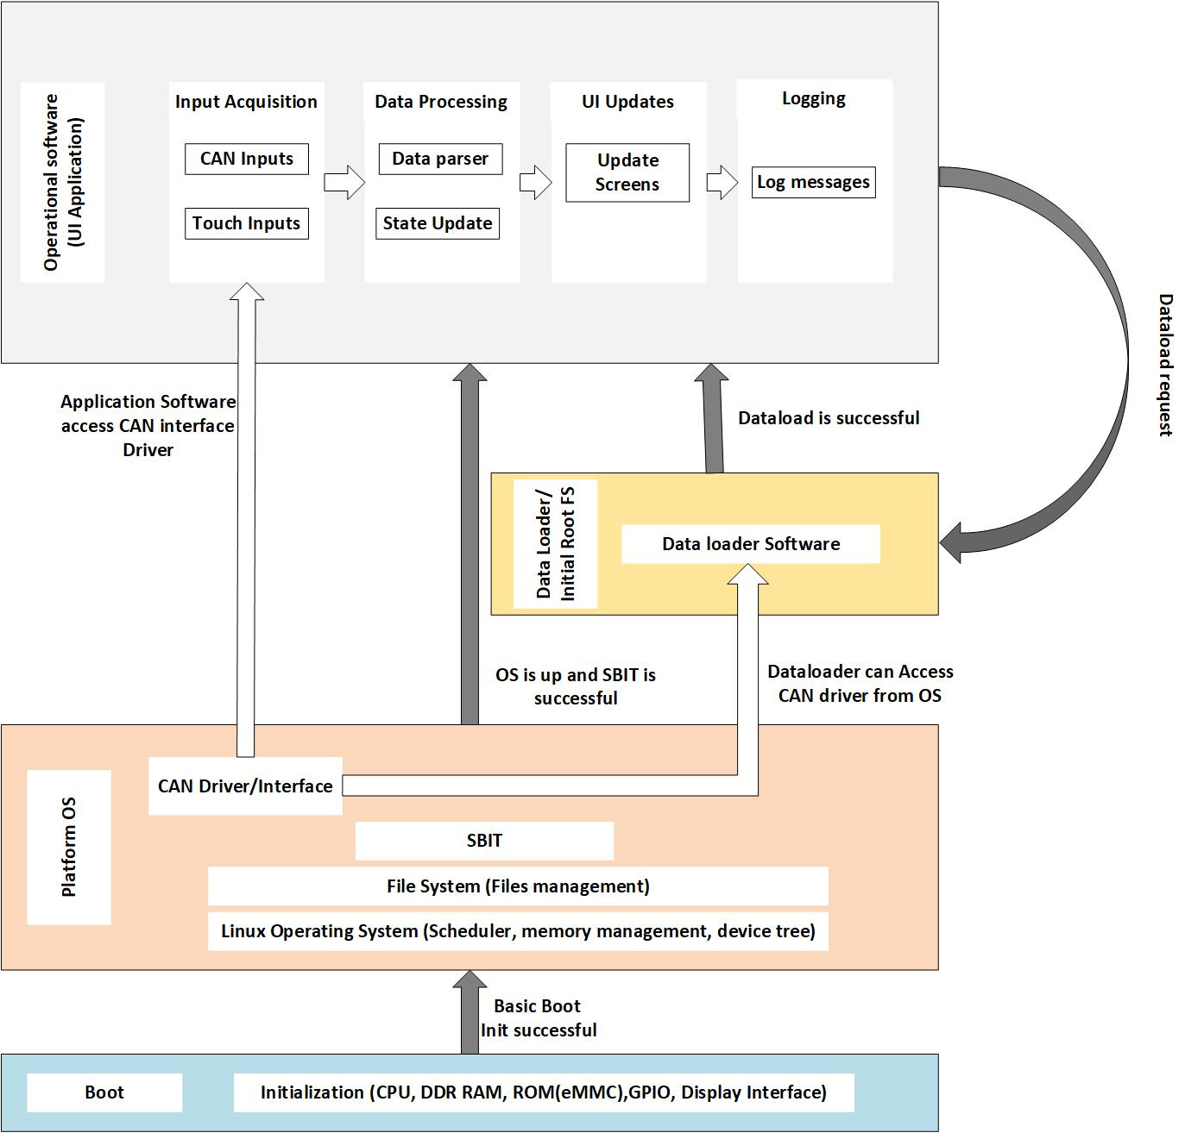
Figure 2 - CDP Software overview

CDP Boot software
Upon power-up the CDP Boot Software (Software bootloader) runs and is responsible for the following function
- Configure CPU settings.
- Configure DDR RAM memory.
- Configure Display interface.
- Load the OS kernel and give the control.
After performing all the steps mentioned above, the bootloader software will transition to CDP Platform software and give the control, in case of any failures CDP Displays the error on the screen and give an option to reboot.

Partitioning
The CDP Bootloader software, CDP Platform software, CDP Dataloader and CDP Operational software have a partitioning that isolates them temporally and spatially, which prevents inadvertent execution of the Bootloader and Data Loader software.
The CDP will power up into the Bootloader software. The Bootloader software loads the Platform software and Initial Root File System. The initial Root File System determines if the control needs to be transferred to Dataloader software or to Operational Software. Any failure will result in the CDP staying in the Bootloader software.
As the CDP Software does not have direct access to physical addresses of the storage, partitioning will be taken care by memory management unit. The details of partitioning will be captured as part of Software Product Specification (Report No: 11751).

Memory Constraints
CDP is equipped with 8GB of DDR4 RAM. Complete Platform Software and Operational Software together will require about 2GB of RAM. CDP does not have any constraints with respect to memory utilization.

High – Level Requirements
The CDP operates in one of the following modes. CDP mode transitions are illustrated in the below Figure 4:
- Off Mode: The CDP is unpowered and the display is off.
- Initialization Mode: Initiated following the application of 28 VDC or at Power on Reset, initializes hardware, software and determines configuration.
- Live data Mode: The CDP enters Live Data Mode after successful initialization and continues to stay in this mode.
- Invalid Mode: The CDP enters Invalid Mode when the initialization is failed.
- Data Loading Mode: The CDP enters Data Loading Mode following the reception of Data load Request.
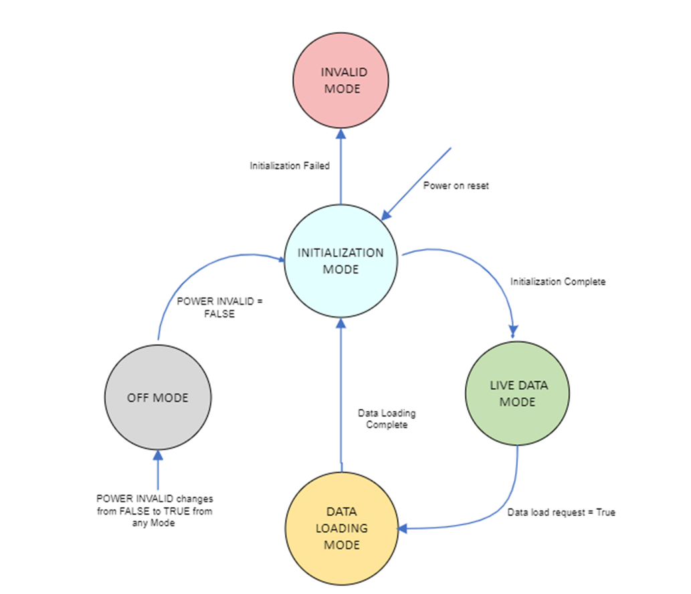
Figure 3 - CDP State Diagram
Once powered up CDP enters Initialization mode. The Bootloader Software runs in Initialization mode, is mainly responsible to Initialize Processor, DDR4 Main memory, Storage (eMMC) interfaces and then load Linux kernel, mount the root filesystem.
ID: CDP-BL-SRS-90377
The CDP Boot Loader Software shall use GRUB in EFI form as the Boot loader.
Applicability: SW
Object Type: Derived
Rational for Derived Req: The HW BIOS (UEFI) will need a Boot Loader to initialize interfaces required for the Linux OS to be loaded. GRUB 2.06 will be used as Bootloader software for CDP.
Verification Method: Analysis
Safety Tag: true
Safety Impact: true
Safety Rationale: This is Derived Requirement. Failure of this requirement is not safety critical and is as per the Design assurance Level D.
LRU Applicability: CDP
ID: CDP-BL-SRS-91321
The CDP Boot Loader Software shall perform the below mentioned tasks in the sequence:
1. Initialize CPU (Intel Atom Processor).
2. Initialize DDR4 Main memory.
3. Perform a RAM Memory test.
4. GPIO initialization
5. UART (Serial port) initialization.
6. LVDS initialization.
7. Check Integrity of Linux Kernel and load it.
8. Check Integrity of Root File System and mount it.
Note: The details of CPU, DDR4 and GPIO are captured from HSIS document (Rpt 11672).
Applicability: SW
Object Type: Decomposed
Verification Method: Analysis
Safety Tag: false
Safety Impact: false
Safety Rationale: NA
LRU Applicability: CDP
ID: CDP-BL-SRS-91438
The CDP Bootloader software shall be developed according to processes defined in RTCA DO-178C / EUROCAE ED-12C, with the Design Assurance Level (DAL) of Level D.
Applicability: SW
Object Type: Verbatim
Verification Method: Inspection
Safety Tag: false
Safety Impact: false
LRU Applicability: CDP
ID: CDP-BL-SRS-90277
The CDP Boot Loader Software shall initialize the CPU (Intel Atom Processor).
Applicability: SW
Object Type: Derived
Rational for Derived Req: Bootloader is responsible to initialize CPU to be in usable state by the Linux OS when loaded
Verification Method: Analysis
Safety Tag: true
Safety Impact: true
Safety Rationale: This is Derived Requirement. Failure of this requirement is not safety critical and is as per the Design assurance Level D.
LRU Applicability: CDP
ID: CDP-BL-SRS-90278
The CDP Boot Loader Software shall initialize the main memory (DDR4) on the SMARC module.
Applicability: SW
Object Type: Derived
Rational for Derived Req: The Linux OS needs to be loaded into the main memory (DDR4), it has to be initialized.
Verification Method: Analysis
Safety Tag: true
Safety Impact: true
Safety Rationale: This is Derived Requirement. Failure of this requirement is not safety critical and is as per the Design assurance Level D.
LRU Applicability: CDP
ID: CDP-BL-SRS-90723
The CDP Boot Loader Software shall test the main memory (DDR4) on the SMARC module, if the test fails, CDP should go to INVALID mode.
Note:
A series of tests will be performed in RAM Test:
- Minimum writeable/readable address in RAM will be verified
- Maximum writeable/readable address in RAM will be verified
- A chunk of memory will be verified by writing to RAM and reading it back to verify if the RAM is working fine.
Applicability: SW
Object Type: Derived
Rational for Derived Req: The functionality of the DDR4 memory should be tested before loading the Platform OS. The Boot loader should carry out a WRITE and READ operation to check the memory functionality.

Verification Method: Analysis
Safety Tag: true
Safety Impact: true
Safety Rationale: This is Derived Requirement. Failure of this requirement is not safety critical and is as per the Design assurance Level D.
LRU Applicability: CDP
ID: CDP-BL-SRS-90343
The CDP Boot Loader Software shall configure the onboard flash (eMMC) on the SMARC module to fetch/load Platform OS software.
Applicability: SW
Object Type: Derived
Rational for Derived Req: The Kernel image and root filesystem to be loaded are to be fetched from the eMMC Flash storage.
Verification Method: Analysis
Safety Tag: true
Safety Impact: true
Safety Rationale: This is Derived Requirement. Failure of this requirement is not safety critical and is as per the Design assurance Level D.
LRU Applicability: CDP
ID: CDP-BL-SRS-90279
The CDP Boot Loader Software shall configure the GPIOs on the SMARC module as mentioned in the Table 4.
Note: The GPIO specifications are provided in smarc_el_user_guide_rev_1-2_2022-09-19.pdf provided by Kontron.
Applicability: SW
Object Type: Derived
Rational for Derived Req: The Discrete IOs are to be used in HW address programming.
Verification Method: Analysis
Safety Tag: true
Safety Impact: true
Safety Rationale: This is Derived Requirement. Failure of this requirement is not safety critical and is as per the Design assurance Level D.
LRU Applicability: CDP
S.No. | SMARC Pin Name | Pin Description | Configured (in/out) | default state | Pin state active high / low | pin function
1 | GPIO0 | GPIO0 PGOOD | Input | High | Active low | power good Holdup cap
2 | GPIO1 | SMARC_ WDG_SET | Output | Low | Active High | Watchdog
3 | GPIO2 | SMARC_WDI | Output | Low | Active High | Watchdog
4 | GPIO3 | /O/E(CAN) | Output | High | Active low | CAN enable
5 | GPIO4 | GPIO IO INT | Input | High | Active low | IO expander interrupt
6 | GPIO5 | GPIO0 USB FAULT | Input | Low | Active High | USB fault
7 | GPIO6 | SMARC_DISCRETE_ADD1 | Input | High | Active low | Discrete input
8 | GPIO7 | SMARC_DISCRETE_ADD2 | Input | High | Active low | Discrete input
9 | GPIO8 | SMARC_DISCRETE_ADD3 | Input | High | Active low | Discrete input
10 | GPIO9 | SMARC_DISCRETE_ADD4 | Input | High | Active low | Discrete input
11 | GPIO10 | SMARC_DISCRETE_PAR | Input | High | Active low | Discrete input
12 | GPIO11 | LCD_BKLT_12V_EN | Output | Low | Active High | BKLT Enable
13 | GPIO12 | PM_Alert | Input | High | Active low | Power monitor
Table 5 - SMARC module GPIO configuration
ID: CDP-BL-SRS-90280
The CDP Boot Loader Software shall configure the dual channel LVDS interface on the SMARC module compatible to the 17” display.
Note 1:
Steps to configure the LVDS.
- The margins of the Display are to be configured.
- The RGB (Red, Green, and Blue) pin configurations of Interface to be initialized.
- Backlight to be powered ON.
Note 2: The sequence of configuring LVDS interface (margins, RGB and backlight) and parameters are available in LCD datasheet. These parameters will be updated in Software product specification (Rpt 11751)

Applicability: SW
Object Type: Derived
Rational for Derived Req: The Height and width and margins of Display and the RGB needs to be configured.
Verification Method: Analysis
Safety Tag: true
Safety Impact: true
Safety Rationale: This is Derived Requirement. Failure of this requirement is not safety critical and is as per the Design assurance Level D.
LRU Applicability: CDP
ID: CDP-BL-SRS-90281
The CDP Boot Loader Software shall validate the integrity of kernel and load it if the kernel is valid.
Note:
- GRUB stores GNU Public Guard keys of the kernel and Root File systems.
- While loading it generates the GPG Keys and verifies them against the stored keys to check if the images are corrupted.
Applicability: SW
Object Type: Derived
Rational for Derived Req: If the kernel is corrupted the CDP will not function. Hence it is required to check the integrity of the kernel before loading it.
Verification Method: Analysis
Safety Tag: true
Safety Impact: true
Safety Rationale: This is Derived Requirement. Failure of this requirement is not safety critical and is as per the Design assurance Level D.
LRU Applicability: CDP
ID: CDP-BL-SRS-90724
The CDP Boot Loader Software shall load kernel from recovery partition state if integrity validation of kernel fails.
Applicability: SW
Object Type: Derived
Rational for Derived Req: The corrupt kernel needs to be replaced with a working kernel from recovery partition.
Verification Method: Analysis
Safety Tag: true
Safety Impact: true
Safety Rationale: This is Derived Requirement. Failure of this requirement is not safety critical and is as per the Design assurance Level D.
LRU Applicability: CDP
ID: CDP-BL-SRS-90725
The CDP Boot Loader Software shall go into INVALID mode if integrity validation of kernel from recovery partition fails.
Applicability: SW
Object Type: Derived
Rational for Derived Req: With a corrupt kernel CDP cannot boot and CDP cannot operate, it should go into Invalid mode.
Verification Method: Analysis
Safety Tag: true
Safety Impact: true
Safety Rationale: This is Derived Requirement. Failure of this requirement is not safety critical and is as per the Design assurance Level D.
LRU Applicability: CDP
ID: CDP-BL-SRS-90352
The CDP Boot Loader Software shall validate the integrity of Initial Root Filesystem and mount it if the Initial Root Filesystem is valid.
Applicability: SW
Object Type: Derived
Rational for Derived Req: If the Initial Root filesystem is corrupted the CDP will not function. Hence it is required to check the integrity of the Initial Root filesystem before loading it.
Verification Method: Analysis
Safety Tag: true
Safety Impact: true
Safety Rationale: This is Derived Requirement. Failure of this requirement is not safety critical and is as per the Design assurance Level D.
LRU Applicability: CDP
ID: CDP-BL-SRS-90726
The CDP Boot Loader Software shall load initial Root File System from recovery partition if integrity validation of Initial Root File System fails.
Applicability: SW
Object Type: Derived
Rational for Derived Req: The corrupt Root File System needs to be replaced with a working Root File System from recovery partition.
Verification Method: Analysis
Safety Tag: true
Safety Impact: true
Safety Rationale: This is Derived Requirement. Failure of this requirement is not safety critical and is as per the Design assurance Level D.
LRU Applicability: CDP
ID: CDP-BL-SRS-90727
The CDP Boot Loader Software shall go into INVALID mode if integrity validation of Initial Root File System from recovery partition fails.
Applicability: SW
Object Type: Derived
Rational for Derived Req: With a corrupt Root File System CDP cannot boot and CDP cannot operate, it should go into Invalid mode.
Verification Method: Analysis
Safety Tag: true
Safety Impact: true
Safety Rationale: This is Derived Requirement. Failure of this requirement is not safety critical and is as per the Design assurance Level D.
LRU Applicability: CDP
ID: CDP-BL-SRS-90345
The CDP Boot Loader Software shall boot kernel and mount initial root file system.
Applicability: SW
Object Type: Derived
Rational for Derived Req: This is the booting step of the Linux OS from bootloader.
Verification Method: Analysis
Safety Tag: true
Safety Impact: true
Safety Rationale: This is Derived Requirement. Failure of this requirement is not safety critical and is as per the Design assurance Level D.
LRU Applicability: CDP
ID: CDP-BL-SRS-90347
The CDP Boot Loader Software shall configure the serial 0 to 115200 baud rate over /dev/tty0 interface.
Note:
- The UART0 Interface is the Serial0 Interface. It will be used as a debug interface to login into the CDP module and track logs/diagnostics.
- All the tasks running on the CDP module can be monitored from this interface
Applicability: SW
Object Type: Derived
Rational for Derived Req: Serial Interface is required for logging into the system. Analyzing logs and state of system requires a serial interface.
Verification Method: Analysis
Safety Tag: true
Safety Impact: true
Safety Rationale: This is Derived Requirement. Failure of this requirement is not safety critical and is as per the Design assurance Level D.
LRU Applicability: CDP

Requirements Traceability Matrix
This section provides the bi-directional traceability matrix between the high level requirements and the system requirements. Note: Derived Requirements in this document are not traced.
# | CIRD ID | Out-links to HLR ID
1 | CDP-CIRD-47946 | CDP-BL-SRS-91321
2 | CDP-CIRD-41435 | CDP-BL-SRS-91438
Table 6 - Forward Requirement Traceability Matrix
# | HLR ID | Object Type | In-links from CIRD
1 | CDP-BL-SRS-91321 | Decomposed | CDP-CIRD-47946
2 | CDP-BL-SRS-91438 | Verbatim | CDP-CIRD-41435
Table 7 - Backward Requirement Traceability Matrix

Appendix A - DO-178C and Supplements Cross - Reference Matrix
DO-178C section | Description | Document Section
11.9 a | Description of the allocation of system requirements to software, with attention to safety related requirements and potential failure conditions. | 7
11.9 b | Functional and operational requirements under each mode of operation. | NA
11.9 c | Performance criteria, for example, precision and accuracy. | NA
11.9 d | Timing requirements and constraints. | NA
11.9 e | Memory size constraints. | 6
11.9 f | Hardware and software interfaces, for example, protocols, formats, frequency of inputs and frequency of outputs. | 7
11.9 g | Failure detection and safety monitoring requirements. | 7
11.9 h | Partitioning requirements allocated to software, how the partitioned software components interact with each other, and the software level(s) of each partition. | 5
Table 8 - DO-178C Cross Reference Matrix

